
No: 24. 2014/15 Cropping Season Review for May 1-10, 2015 and Outlook for May 11-20, 2015

HIGHLIGHT
- During May 1-10, 2015, good rainfall performance was observed over some areas of the country particularly coastal region and Lake Victoria basin but it was associated with flooding conditions in Dar-es-Salaam city and parts of Morogoro region.
- The expected rainfall over the bimodal areas during May 11-20, 2015 may be favorable for crops development but farmers are advised to seek professional advice from nearby Agricultural and livestock extension officers.
- Where thunderstorms and showers are predicted, farmers are also advised to take precautionary measures for their safety and properties.

SYNOPTIC SUMMARY DURING

MAY 1-10, 2015

During May 1-10, 2015, the northern hemisphere high pressure systems (Azores and Siberia) continued to relax whereas the southern hemisphere high pressure systems (St. Helena and Mascarene) continued to intensify. Over land, the East Africa Ridge dominated over the south-western and central parts of Tanzania hinter lands. Warm Sea Surface Temperatures (SSTs) were observed over the north western Indian Ocean closer to East African coast while neutral to slightly warm SST pattern was observed over the Eastern and Central Indian Ocean. This configuration made the Meridional arm of the Inter-Tropical Convergence Zone (ITCZ) to shift slightly east ward towards western part of the country. The zonal arm of the ITCZ on the other hand, moved north wards to cover the northern part of Tanzania thus reducing the ITCZ rainfall influence to the southern part while enhancing rains over the coastal strip of the country.

WEATHER SUMMARY DURING

MAY 1-10, 2015

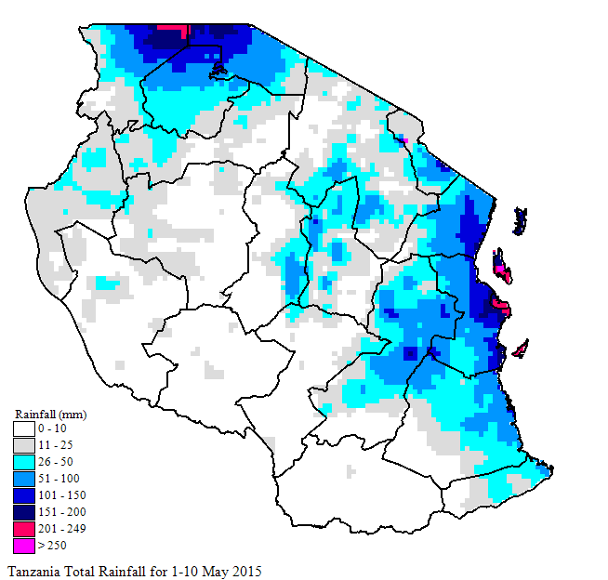
Figure 1: Spatial total rainfall distribution (mm) during May 1-10, 2015
With the observed synoptic conditions during May 1-10, 2015, good rainfall performance was observed over some areas of the country while others experienced dry conditions. Good performance was over the coastal regions, parts of Lake Victoria basin, central areas, western and north-eastern highlands where as dry conditions were experienced over the southern region, south-western highlands and parts of west and north-eastern highlands. As shown in Figure 1 (Satellite Rainfall Estimates merged with gauge data from Tanzania rainfall stations network showing spatial total rainfall distribution), the highest total rainfall was observed at Zanzibar (400.5 mm) followed by Pemba 249.6 mm), Julius Nyerere International Airport (241.0 mm), Lyamungo (210.8 mm), Matangatuani (198.0 mm), Kibaha (181.8 mm), Bukoba (160.1 mm), Dar-es-Salaam Port (142.1 mm), Mahenge (123.6 mm), Arusha (113.2 mm), Handeni (97.6 mm), Kilwa Masoko (94.1 mm), Mtwara (81.1 mm), Morogoro (79.2 mm), Tanga (75.3 mm), Kilimanjaro International airport (65.6 mm), Mlingano (59.0 mm), Naliendele (54.5 mm) and Musoma (53.0 mm). The remaining areas received less than 51 mm. Figure 2 also shows rainfall performance during the dekad as percentage of long term average whereby above normal rainfall was received over the coastal regions, part of central, Lake Victoria basin and north-eastern highlands. The rest of the country received normal to below normal rainfall.
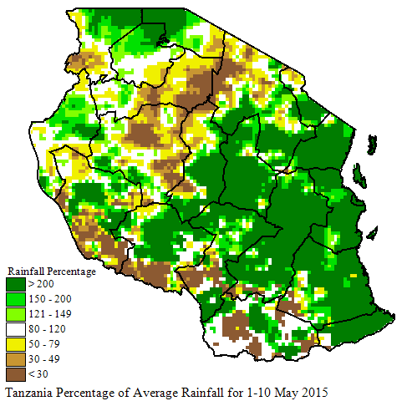
Figure 1: Rainfall performance during May 1-10, 2015 as percentage of long term average.

AGROMETEOROLOGICAL SUMMARY DURING MAY 1-10, 2015

During May 1-10, 2015, the observed rainfall was reported to have provided adequate soil moisture for crops and development of pasture. Over the bimodal areas, maize crop has started to tassel in Mara, Mwanza, Kilimanjaro, Coast and Tanga ragions. Despite the observed heavy rainfall along the coast during the dekad, crops were reported to be in good condition over Tanga, Coast and Kilimanjaro regions, except over Dar-es-Salaam and morogoro region where there were flooding conditions. In Dar-es-Salaam city, flooding caused death of people and damage of properties. Over the unimodal areas, maize crop is at full ripenes stage.

HYDROLOGICAL CONDITIONS

DURING MAY 1-10, 2015

Water levels in dams and river flow discharges were moderate in most areas of the country, but slight improvements were observed over the coastal areas.

ENVIRONMENTAL CONDITIONS DURING

MAY 1-10, 2015

During May 1-10, 2015 moderate to cool temperature conditions prevailed across the country. Flooding conditions were also reported in Dar-es-Salaam city and parts of Morogoro region.

EXPECTED SYNOPTIC CONDITIONS DURING MAY 11-20, 2015

During the period of May 11-20, 2015, the high pressure systems in the northern hemisphere are expected to remain relaxed while their counterparts in the southern hemisphere are expected to continue intensifying. With this configuration, the ITCZ is expected to continue moving northwards. This shifting is expected to influence weather in the country such that seasonal rains are expected to end over the remaining parts of the unimodal areas whereas over the bimodal areas (northern coast, north-eastern highland and Lake Victoria basin), the masika rains are expected to continue. Neutral to warm SSTs are expected over Atlantic Ocean closer to Angola coast. Neutral to slightly warm

SSTs are expected over the East Africa coast while warm SSTs are expected over the Somali coast in the West Indian Ocean. Low level wind speed is expected to start rising over some parts and is expected to be characterized by south-easterly and westerly wind convergence over the western and south-western areas. Over the remaining parts of the country, south-easterly turning to southerly wind is expected.

EXPECTED WEATHER DURING

MAY 11-20, 2015

Lake Victoria Basin (Kagera, Mwanza, Mara, Geita, Simiyu and Shinyanga regions) and northern coast (Dar es Salaam, Morogoro and Tanga regions, the isles of Unguja and Pemba): thunderstorms and showers over some areas are expected. North-eastern highlands (Kilimanjaro, Arusha and Manyara regions): thunderstorms and showers over few areas are expected especially during the first half of the dekad. Western regions (Kigoma and Tabora regions), south-western highlands (Rukwa, Iringa and Mbeya regions), southern coast (Mtwara and Lindi regions) and southern region (Ruvuma region): rain showers with occasional thunderstorms over few areas are expected. Central areas (Dodoma and Singida regions): rain showers over few areas are expected during the period. Seasonal rains are expected to end over the remaining part of the unimodal areas within the dakad.

AGROMETEOROLOGICAL OUTLOOK AND ADVISORY DURING MAY 11-20, 2015

During May 11-20, 2015, the expected rainfall over the bimodal areas may be favorable for crops development but farmers are advised to seek professional advice from nearby Agricultural and livestock extension officers. Where thunderstorms are predicted, farmers are also advised to take precautionary measures for their safety and properties.

HYDROLOGICAL OUTLOOK DURING MAY 11-20, 2015

Prepared by
TANZANIA METEOROLOGICAL AGENCY
3rd, 4th& 10 ^{th} Floors - Ubungo Plaza – Morogoro Road.
P.O. Box 3056 Tel. 255 -(0) 22 – 2460706-8 ; Fax: 255 - (0) 22 – 2460718 E-mail: (1) met@meteo.go.tz (2) agromet1_tz@meteo.go.tz
Dar es Salaam UNITED REPUBLIC OF TANZANIA

During May 11-20, 2015, water levels in dams and river flow discharges are expected to remain moderate over most parts of the country.

