 | The Gambia Meteorological Services  Department of Water Resources  7 Marina Parade

Monthly Climate Bulletin
N⁰ 9 Octobre-Novembre-December 2015

1.0 Station history of The Gambia Meteorological Network & rainfall stations

The Gambia Meteorological Services used to operate fifteen (15) Weather Observing stations covering all the regions in the country, but these were reduced to ten (10) in 2008. As of now, the department operates ten (10) Synoptic weather stations, one (1) Marine Automatic Weather Station and 25 rainfall measuring stations.

  - Network of Meteorological Stations.

Figure 1 shows Network of Meteorological stations in black symbols, 24 hour stations in blue symbols and red symbols for stations which were closed in 2008. The green symbols are the proposed new stations.

- Day light stations
- 24 hour stations
- Stations closed
- Proposed new Stations in 2014

Figure 1 : Network of Meteorological station

  - Part 1:
Table 1: Recorded Rainfall in millimetres (mm) for October-November-December 2015

Station | R_tot | Normal_1981-2010 | R_Max | R_Max_date | R_Min |  | R_Min_date
Banjul | 68.2 | 66.5 | 35.6 | 21st October | 1.3 | ^{20th October}
Yundum Airport | 55.6 | 57.3 | 22.9 | 22nd October | 0.4 | ^{15th October}
Kerewan | 92.2 | 71.4 | 49.0 | 02nd October | 1.5 | ^{24th October}
Sibanor | 128.2 | 57.1 | 26.8 | 22nd October | 0.8 | ^{03rd November}
Kaur | 75.5 | 58.2 | 26.8 | 22nd October | 1.6 | ^{07th October}
Jenoi | 88.5 | 57.0 | 56.6 | 22nd October | 1.2 | ^{15th October}
Sapu | 101.0 | 74.4 | 54.0 | 06th October | 0.5 | ^{21st October}
Janjanbureh | 114.0 | 57.7 | 33.5 | 06th October | 1.0 | ^{21st October}
Basse | 39.2 | 21.2 | 28.4 | 06th October | 1.3 | ^{14th October}
Fatoto | 161.0 | 61.6 | 48.9 | 06th October | 5.1 | ^{26th October}
Kuntaur |  | 55.8
Somita |  | 45.5
Bakendik |  | 56.0
Kuntair | 88.0 | 58.8 | 54.0 | 22nd October | 4.0 |  | 25th October
Ngain-Sanjal | 174.0 | 62.7 | 55.0 | 22nd October | 2.0 |  | 11th October
Njabakunda | 74.4 | 72.8 | 40.0 | 05th October | 3.9 |  | 01st November
Jambanjelly |  | 59.0
Pirang |  | 66.9
Karantaba |  | 67.7
Kwinella |  | 62.1
Yalla |  | 64.0
N’jau |  | 50.5
Dankunku |  | 54.4
Gibanak |  | 47.4
Jahkunda |  | 66.0
Bansang |  | 20.6
Saresofi | 113.1 | 52.1 | 35.1 | 07th October | 4.0 |  | 10th October
Mankamang | 91.9 | 67.4 | 30.4 | 11th October | 10.2 |  | 14th October
Girobakunda |  | 61.3
Jali |  | 43.2
Kanjibat | 62.7 | 45.3 | 34.0 | 22nd October | 3.4 |  | 14th October
Serrekunda | 76.7 | 61.9 | 38.2 | 02nd November | 5.3 |  | 15th October
Sutukoba |  | 51.9
Naude |  | 64.5

    - Rainfall distribution

Figure 2 indicates significant rainfall amounts for the period October-November-December with values ranging between 100 to about 175 mm over the greater part of the country. In Table 2, the highest record of 174mm prevailed at Ngain Sanjal at the north bank and the lowest value of 39.2 was observed at Basse the eastern part of the country. The country average seasonal rainfall during this period stood at 94.4mm, which is 65% above the long term mean (57.1mm) of 1981-2010 and a surplus 37.3mm.

Figure 2: Rainfall (mm) for OND 2015

1.2.2 Temperature variations

The graph in figure 3 illustrates temperature variations over the country with the highest absolute temperature of 36.7⁰C over Basse at the eastern sector and a lowest absolute minimum of 13.1⁰C over Fatoto. Janjanbureh observed the highest maximum temperature of 34.8⁰C, whilst Fatoto recorded the lowest minimum value of 16.4 ⁰C.

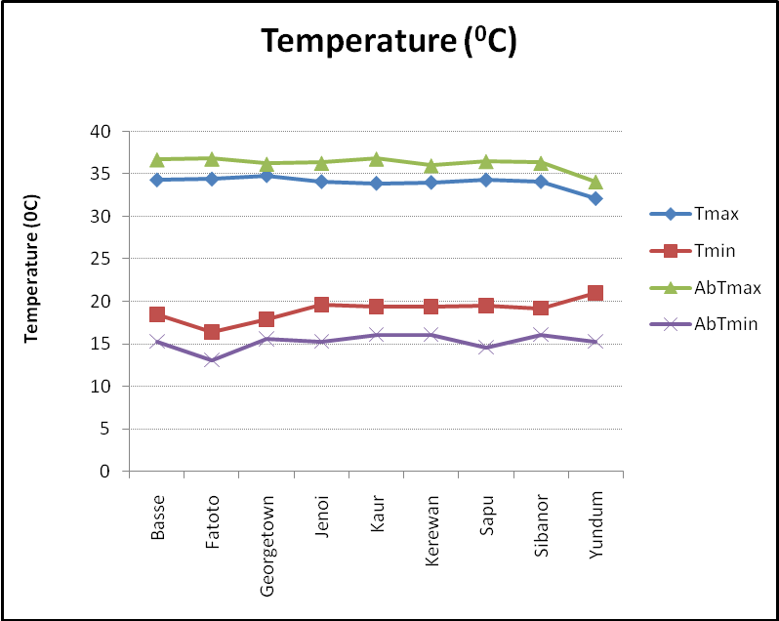

Figure 3: Mean temperature (⁰C) variations for OND

1.3 Part II :
Table 2: Temperature in degrees Celsius (0C) for October-November-December 2015.
Station _codes |  |  | MeanT-2015 | Normal  1981-2010 | MeanTmax-  2015 | Normal  Tmax | MeanTmin-2015 | Normal  Tmin | AbTmax-_2015 | Normal  Hig max T | AbTmin_2015 | Normal  Low min T
WMO | National | Name
61711 | 15003000 | Banjul Halfdie/Marina | * | 28.0 | * | 33.3 | * | 22.8 | * | 33.9 | * | 20.4
61731 | 15001200 | Basse | 26.5 | 27.1 | 34.3 | 35.3 | 18.5 | 18.9 | 36.7 | 36.3 | 15.3 | 15.1
61733 | 15006600 | Fatoto disp./met. | 25.4 | 27.2 | 34.4 | 35.6 | 16.4 | 19.2 | 36.8 | 36.5 | 13.1 | 15.5
61721 | 15003900 | Georgetown | 26.3 | 27.1 | 34.8 | 35.4 | 17.9 | 18.7 | 36.2 | 36.6 | 15.6 | 15.5
61707 | 15004900 | Jenoi | 27.0 | 26.8 | 34.1 | 34.9 | 19.6 | 18.7 | 36.3 | 35.8 | 15.3 | 15.0
61717 | 15000600 | Kaur | 26.6 | 27.6 | 33.9 | 35.3 | 19.4 | 20.0 | 36.8 | 36.4 | 16.1 | 17.5
61712 | 15003300 | Kerewan | 26.8 | 27.3 | 34.0 | 34.5 | 19.4 | 20.0 | 36.0 | 35.4 | 16.1 | 17.2
61722 | 15006200 | Sapu | 26.9 | 26.6 | 34.3 | 35.1 | 19.5 | 18.4 | 36.5 | 36.0 | 14.6 | 14.4
61705 | 15005900 | Sibanor | 26.7 | 26.6 | 34.1 | 34.4 | 19.2 | 19.0 | 36.3 | 34.9 | 16.1 | 15.2
61701 | 15005400 | Yundum Airport | 26.2 | 26.7 | 32.1 | 33.1 | 21.0 | 20.2 | 34.1 | 33.7 | 15.3 | 20.0

  - Part III:

Table 3: Relative Humidity in percentage (%) and Wind in metres per second (m/s) for
October-November-December 2015.
Station Codes |  |  | Relative Humidity (%) |  |  |  | Windspeed (m/s)_2015
WMO | National | Name | MeanRH_2015 | 1981-2010 | MaxRH_2015 | MinRH_2015 | Mean | Highest
61711 | 15003000 | Banjul Halfdie/Marina | * | 63 | * | * | * | *
61731 | 15001200 | Basse | 65 | 64 | 94 | 25 | 2.1 | 15
61733 | 15006600 | Fatoto disp./met. | 56 | 57 | 97 | 25 | 5.5 | 11
61721 | 15003900 | Georgetown | 56 | 60 | 97 | 26 | 3.1 | 20
61707 | 15004900 | Jenoi | 60 | 57 | 95 | 30 | 3.6 | 9
61717 | 15000600 | Kaur | 54 | 52 | 95 | 24 | 2.9 | 19
61712 | 15003300 | Kerewan | 67 | 59 | 91 | 32 | 6.8 | 12
61722 | 15006200 | Sapu | 55 | 58 | 98 | 24 | 4.4 | 19
61705 | 15005900 | Sibanor | 72 | 63 | 99 | 38 | 1.5 | 17
61701 | 15005400 | Yundum Airport | 64 | 70 | 97 | 35 | 3.7 | 21

1.5 Part IV:
Table 4: Sunshine (hours) and Evaporation (mm) for October-November-December 2015.

Station_codes |  |  | Sunshine 2015 |  |  |  | Evaporation Class A (mm) 2015
WMO | National | Name | Total | Normal_1981-2010 | Max | Min | Total | Mean
61711 | 15003000 | Banjul Halfdie/Marina | * | * | * | * | * | *
61731 | 15001200 | Basse | 202.5 | 192.2 | 10.3 | 0.6 | 103.8 | 4.3
61733 | 16006600 | Fatoto disp/met. | 162.5 | 86.7 | 10.6 | 4.7 | 159.3 | 5.2
61721 | 15003900 | Georgetown | 227.3 | 147.1 | 10.2 | 1.7 | 122.6 | 4.0
61707 | 15004900 | Jenoi | 199.5 | 181.5 | 9.8 | 1.5 | 119.6 | 3.9
61717 | 15000600 | Kaur | 227.2 | 99.7 | 10.4 | 2.6 | 121.0 | 4.4
61712 | 15003300 | Kerewan | 220.9 | 201.8 | 10.2 | 1.1 | * | *
61722 | 16006200 | Sapu | 140.9 | 125.9 | 8.7 | 6.1 | 137.1 | 4.0
61705 | 15005900 | Sibanor | 212.8 | 116.5 | 10.2 | 0.9 | 88.7 | 2.9
61701 | 15005400 | Yundum Airport | 175.0 | 218.5 | 10.3 | 2.7 | 123.6 | 4.0

2.0 Part V: Climate Report explanations

PREFACE
Selected climatologically data of general importance from weather stations in The Gambia has been compiled in this report. Blank spaces indicate either missing or delayed records. If data are missing for one day or several days for one station within the selected period, the station concern it is marked with an as terix (*). Observed values (OBS) and the normals (NORM) of these data values from the long period averages are given for the following elements:
- Average air temperature
- Rainfall
- Relative Humidity
- Sunshine
- Interpolated map for rainfall is included.

EXPLANATION OF TABLES

- Rainfall (mm) amount is measured every six hours using a standard rain gauge placed 80cm above ground level. The Total rainfall amount for any given day is the cumulative or accumulated six hourly rainfall amounts. A Rainy day is defined as a day with a total rainfall amount equal or more than 1mm.

- Air Temperature (°C) observations are made from thermometers exposed in Stevenson Screens, 1.25 metres above the ground. The Maximum and Minimum Temperature (°C) observed/ obtained, indicates the highest and lowest temperatures during the specified period.

- Relative Humidity is derived from the readings of the dry and wet bulb thermometers and expressed in Percentage (%).

- Sunshine Duration is measured using a Campbell-Stokes Tropical Sunshine Recorder and is recorded in hours.

- Actual Evaporation is determined from a Class A Pan and measured in millimetres (mm).
- Wind speed is read from a Cup Counter Anemometer mounted 10 metres above the ground and read in knots. It can also be converted to metres per second (m/s) or kilometre per hour (km/h).

Abbreviations :
- MeanT : Mean Temperature
- Mean Tmax : Mean Maximum Temperature
- Mean Tmin : Mean Minimum Temperature
- Highest M T: Highest Maximum Temperature
- Lowest M T : Lowest Minimum Temperature

Published by: Climate Unit
Department of Water Resources
7 Marina Parade
Banjul, The Gambia
Telephone: 00 (220) 422-7631/4222-872/422-4122
Fax: 00 (220) 422-5009
http://www.mofwrnam.gov.gm
E-mail: info@mofwrnam.gov.gm; infoclimate@gmail.com

